**AZ-104: Prerequisites for Azure administrators**

**Manage resources with Azure CLI:**

Az group –help

**To Create Resource Group:**

az group create --name demoResourceGroup --location centralindia

az group list

**To Create Storage Account:**

az storage account create --resource-group demoResourceGroup --name storage_gopi --location centralindia --sku Standard_LRS --kind StorageV2

**To Create Lock:**

az lock create --name LockGroup --lock-type CanNotDelete --resource-group exampleGroup

az lock list --resource-group exampleGroup

az lock delete --name exampleLock --resource-group exampleGroup

**Use Azure Resource Manager:**

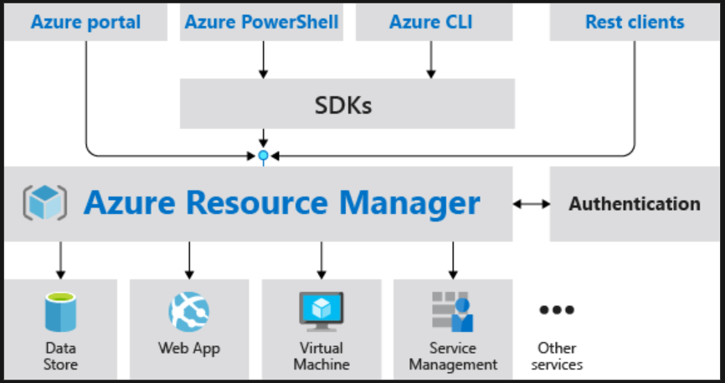

**Azure Resource Manager provides several benefits:**

* You can deploy, manage, and monitor all the resources for your solution as a group, rather than handling these resources individually.
* You can repeatedly deploy your solution throughout the development lifecycle and have confidence your resources are deployed in a consistent state.
* You can manage your infrastructure through declarative templates rather than scripts.
* You can define the dependencies between resources so they're deployed in the correct order.
* You can apply access control to all services in your resource group because Role-Based Access Control (RBAC) is natively integrated into the management platform.
* You can apply tags to resources to logically organize all the resources in your subscription.
* You can clarify your organization's billing by viewing costs for a group of resources sharing the same tag.

**Azure resource terminology:**

* resource - A manageable item that is available through Azure. Some common resources are a virtual machine, storage account, web app, database, and virtual network, but there are many more.
* resource group - A container that holds related resources for an Azure solution. The resource group can include all the resources for the solution, or only those resources that you want to manage as a group. You decide how you want to allocate resources to resource groups based on what makes the most sense for your organization.
* resource provider - A service that supplies the resources you can deploy and manage through Resource Manager. Each resource provider offers operations for working with the resources that are deployed. Some common resource providers are Microsoft.Compute, which supplies the virtual machine resource, Microsoft.Storage, which supplies the storage account resource, and Microsoft.Web, which supplies resources related to web apps.
* template - A JavaScript Object Notation (JSON) file that defines one or more resources to deploy to a resource group. It also defines the dependencies between the deployed resources. The template can be used to deploy the resources consistently and repeatedly.
* declarative syntax - Syntax that lets you state "Here is what I intend to create" without having to write the sequence of programming commands to create it. The Resource Manager template is an example of declarative syntax. In the file, you define the properties for the infrastructure to deploy to Azure.

**Create Azure Resource Manager locks:**

You can associate the lock with a subscription, resource group, or resource.

Locks are inherited by child resources.

**Lock types:**

There are two types of resource locks.

* Read-Only locks, which prevent any changes to the resource.
* Delete locks, which prevent deletion.